D5000/D5000M Series Sensor Connection Diagrams
The D5000 aand D5000M series four channel analog input connection diagram. The terminals are referenced as CH0, CH1, CH2, and CH3. These are the positive inputs of the channel.
The Analog Ground terminal A.GND is the signal common for the four channels. This terminal is isolated from the Power Supply Ground (GND) terminal by up to 500Vrms.

Typical Voltage, Thermocouple, or Thermistor Input Connections
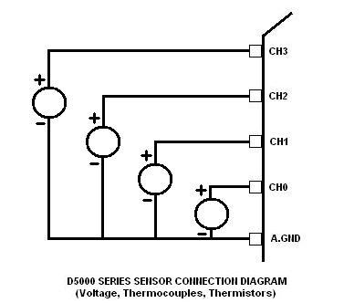
Typical 4-20mA Transmitter Connections
